CDCC Parent Newsletter
October 2018

Important Dates to Remember
Oct. 8 - Pumpkin Patch Field Trip 9:00am
Oct. 11- Picture Day will start around 9:00am
Oct. 11- Parent Seminar 5:30pm
Oct. 23 - Woman’s Get Together - Prep for Fall Festival
Oct. 27 - Fall Family Festival 11:30am-2:30pm
Save the Date: Dec. 13 CDCC Christmas Program 6:30pm

Volunteers needed
There are two volunteer opportunities open right now. We are looking for volunteers to make and serve our morning snack on Tuesdays and Fridays. A full background check is required for this volunteer position (CDCC covers this cost). We are also looking for someone to oversee our Scholastic Book Club this year. It is a great way for a parent to purchase inexpensive books and earn free books for the school. Please let me know if you or a family member are interested in these volunteer opportunities.

Remind App This is how we will communicate in an emergency: You will receive messages individually tailored for your child's class as well as messages for the whole school. If you want notifications through the app on your smartphone, enter the appropriate class code from the list below as a website into your web browser. The link will prompt you to download the mobile app. Sign up for Remind now!
- Miss Gloria's Class: rmd.at/cdccps1
- Miss Halie’s Class: rmd.at/cdccps2
- Miss Alyssa's Class: rmd.at//cdccps3
- Miss Laura’s Class: rmd.at//cdccps4
- Miss Delanie’s Class: rmd.at//cdccpk1
- Miss Cathy's & Miss Veronica's Class: rmd.at/cdccpk2
- After Kindergarten: rmd.at/cdccak
- After School: rmd.at/cdccas
Amazon Smile
If you shop on Amazon.com you can earn money for the Cliff Drive Care Center. Amazon donates a portion of all of the sales made through their website: smile.amazon.com. You use it exactly as you would use their amazon.com address. Simply go to smile.amazon.com every time you shop. On your first order through Amazon Smile, they will ask you to choose a non-profit. Search for Cliff Drive Care Center and choose us!

Pumpkin Patch Field Trip-October 8
We will be leaving for Lane Farms at 9:00am Monday morning. This is a very fun field trip which includes farm animals, hay rides and picking out pumpkins. If you are able to be a parent driver, please contact Jenny at 805-453-3403.

Picture Day-October 11
We will begin with the two year old class and work our way through the school. If Tuesday is not your child’s normal school day, please feel free to bring your child for photos and stay with them until they are finished.

Parent Seminar -October 11th 5:30pm-7:30pm
We will have a panel of teachers: Jenny Yznaga and Delanie Sabac (Cliff Drive Care Center Pre-School); Loriann Mastromarino and Caren Roberts (First grade teachers, Hollister School) to discuss how to best partner with teachers, help your kids at home, and create an environment for healthy and successful learning. Dinner will be provided. Please RSVP to childcare@fmcsb.org by Thursday, October 4.
Women’s Event Preparing for Fall Family Festival -October 23, 6pm-8:30pm This will be a time for women to gather and help prepare for the annual Fall Family Festival. Pastor Doug and Stefanie will put us to work ;) It is a great way to meet and connect with other women! Soup dinner and childcare provided. RSVP to childcare@fmcsb.org by October 20th.
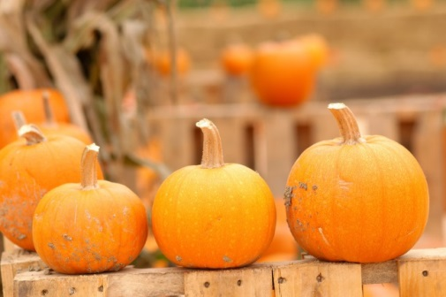
Fall Family Festival You are invited to join us for our annual Fall Family Festival! Sat. Oct. 27, 11:30am-2:30pm
Games, crafts, a bounce house, face painting, candy and fun for the whole family. Children of all ages are invited to participate in Trunk or Treat from 12:00-1:30pm. Free popcorn, snow cones and cotton candy. A tri-tip BBQ or hotdog meal is available for purchase.
- Volunteers are also needed to run games and activities. Let us know if you are willing to help!
- This is a fun, family event worth attending. Invite your friends to join us in the Free Methodist Church parking lot! (Please, no scary or violent costumes)

October Chapel Themes
October 3 – Noah, Part 2 - Promises
October 10 - Abram goes to a new land - Obedience
October 17 - Jacob takes his brother's blessing - Honesty
October 24 - The story of Joseph – Faithfulness
October 31- Baby Moses - Providing

Sincerely,
Jenny Yznaga, Director

